Event Experience & Career Development
Unfortunately, during this semester, I had zero chance to attend a large scale event. I was hoping to go to MegaCon Orlando, an event I wrote about for the previous assignment. But it didn’t work out. Tickets were sold out, I had a new foster dog that couldn’t be left alone, and I had just lost one of my dogs to cancer. On top of all that I have a full-time job as a trainer and software developer.
However, as part of my job, I attend many different online events. They’re all geared towards technology: website building, Claris FileMaker app building, and artificial intelligence. I’ve attended, have hosted, and have spoken at dozens of user group Zoom events in the last six months. So I share my thoughts on those.
These kinds of events are valid and not often studied. Our readings mention these I believe, but it isn’t something really studied too much. These are events, people register, and there are speakers. While a speaker here doesn’t need a “deck manager”, nor are there load-in and load-out crews to work with, online events present their own unqiue challenges.

Event Overview
Clear, detailed summary of the event or networking experience; includes 5 W’s or key context
The most recent event I attended was on Friday, April 17, 2026. It is a user group called FMDisc that talks about development in the Claris FileMaker Platform. The group meets the 2nd Tuesday each month over Zoom. It is hosted by one of three hosts who secure the speakers, set the agenda, and send out invitations. They welcome everyone to the Zoom and introduce each speaker.
The purpose of the monthly meeting is to promote the use Claris FileMaker (a database-building platform), showing off new or studied techniques, and introduce new technologies. Each of the three segments during the 3-hour event has a different speaker and a different topic. In between the 2nd and 3rd session is a breakout time where the host uses the Zoom feature “breakout rooms” to give the 30-40 attendees a chance to interact with others. We’re all put into those rooms, see who’s in there, and inevitably say hi to other attendees we already know (this is a small community overall).
Each session in the time lasts between 45 minutes and 75 minutes depending on the need of the speaker. Speakers are people who have a new technique or a new product or demo file to demonstrate. These speakers are selected and are tasked with furthering the platform’s adoption and use. They also work to inspire the other attendees. Sometimes one of the segments is a “Get to Know You” session where the host interviews someone in our community.
I have presented many times at this event. I usually share some web-building concept. In July I plan on presenting about dealing with large sets of data in the FileMaker platform. I’m well-known and speak at these a lot at this and other online FileMaker user groups.
One note: this group meets virtually. They didn’t used to. Before the pandemic only those in the Burbank CA area attended an in-person session. Like thousands of others, the pandemic caused this group to go virtual instead.

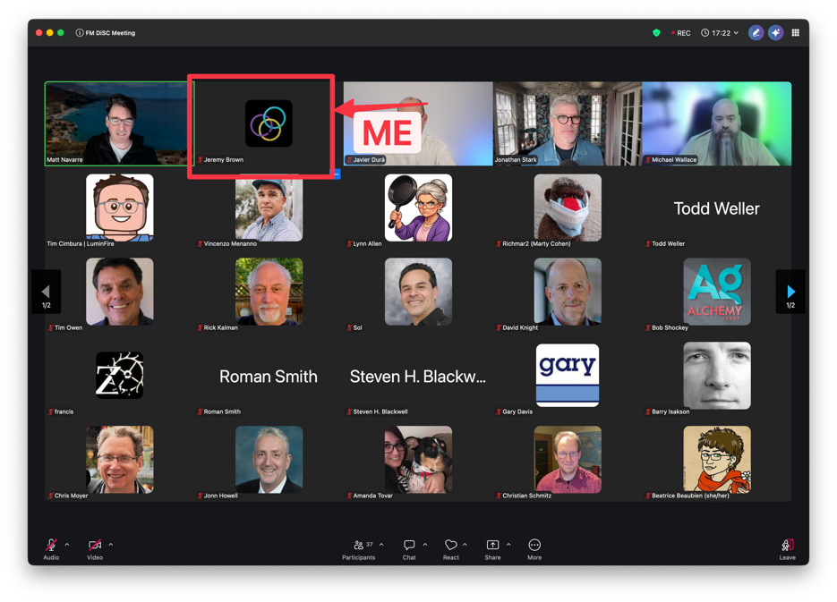
Engagement
Clearly explains the student’s role, participation, and actions taken; shows thoughtful involvement
When I am an attendee only and not a speaker I stay engaged in the event. It is online and there’s a lot of opportunities for the session to feel impersonal and for the speaker to feel isolated. So, I stay engaged by keeping my camera on and keeping my focus on the speaker’s thoughts and demonstrations. I know from experience having people engaged in what you’re talking about as a speaker is motivating and encouraging. It is quite a challenge for me to do so; my two computer screens display the Zoom session as well as social media sites, work that I should be doing, or private Slack conversations. I try to put all of that away and focus on the session at hand.

When I am a speaker, as I was a few months ago, I try to do something to make the Zooms better. Again, as a participant I know it is easy to not be tuned into the speaker. And since most speakers simply show PowerPoint slides and demos of the code they’re writing, it is pretty much the same. I try to incorporate technologies into my demonstrating in the form of online poll services. I ask questions and solicit responses from people to encourage participation. I was a teacher for fifteen years, so I try to employ all those.
Recently I proposed a ‘work session’ at one of the scheduled times of this group where I’d pass out a database with some basic set up code and have people code along with me. The facilitators of the group liked the idea but they recognize a zoom event for what it is: a place where people gather, most of which are only half-listening. Anyway, I try to mix up what I do and make it more engaging. Honestly, I’m not sure it eve works out.

Refection & Insights
Demonstrates critical thinking, personal insight, and thoughtful reflection on successes, challenges, and lessons learned
I’ve already mentioned above some thoughts I have about how I participate. I really try to be a source of energy for the speaker, and as a speaker I try to be engaging.
Zoom meetings are tough and full of pros and cons. On the pro side, people from all over the world can attend. This FMDisc group opened its doors, so to speak, when they went all virtual. It has greatly enhanced the diversity of the speakers, and in turn, the range of topics demonstrated. When I attend, I get to see people I know only from these meetings or that I met years ago at a larger industry-wide conference in person. Virtual meetings allow the presenter to share their screen where everyone has access to it. No one is seated too far away from the screen to see what’s happening. And the Zoom technology gives me the chance to ask questions, to raise my hand and talk to a smaller group of people during those breakout sessions.
However, Zoom meetings isolate me and others even further. Watching an event from my own desk forces me to make an extra-concentrated effort to attend to the speakers. By staying home, I only must have the bare minimum effort: open the meeting link and at least have a shirt on when I use my camera. I have not put extra effort in getting to the physical location of the event, and I would never bring my computer there only to surf other sites. So, I must really tune my attention to the window that shows the demonstration happening.
Also, despite this group’s best efforts of bringing us together with those breakout small rooms, it is still just each of us talking into our cameras and mics. I enjoy talking with the folks in the little squares next to mine but I’m still all alone.
Technology can deter from an enjoyable experience. Every meeting I attend, someone has forgotten to mute their mic. Inevitably that person has a conversation with someone else outside the meeting and we can hear them talk. It’s disruptive to the speaker and throws everyone off. I was guilty of that one time and I get embarrassed thinking about that.
Also sometimes the speaker’s presentation is really just too small to see well. Their bandwidth may be slow and so their presentation and voice cut in and out. It’s really distracting to have all that happen.
The organizers try to mitigate all this by using technology to test, to mute everyone, and to encourage folks to use the chat to ask questions. But someone manages to throw a small wrench in the smooth operation of the event.

Analysis
Strong evaluation of the event’s logistics, operations, or value; SWOT is well-developed and accurate
Online events have great strengths, weaknesses, opportunities, and threats.
I’ve mentioned a few above but let’s list them here:
Strengths  - Diversity of speakers  - Diversity of attendees  - Technology for engagement  - More events: more occurrences or additional similar events.  - Speakers share their screens without any special prep  - No need for finding a physical location and deal with all the challenges that location brings.  - Easy to swap out one speaker for another in case of a cancellation. | Weaknesses  - Harder to get everyone engaged.  - Technology glitches always happen.  - Isolating for all involved.  - The speaker feels alone talking into the void.
Opportunities  - There needs to be some tech advancement that encourages engagement stronger.  - Getting people used to the tools of the online meeting platform, such as chatting, polls, AI summaries, etc. | Threats  - The threats are ones that interrupt the flow of the event:  - Participant mics unmuted.  - Internet crashes.

Professional Relevance
Clearly connects the experience to future career goals or development; explains continued interest or next steps
I have a strong stake in making online events as good as possible. By participating in various online events while taking this class, I’m interested in finding great ways to make online events better.
My stake comes in the form of a community that I’ve developed. I have the JS in FM Community, where I host over 400 people and lead them in weekly Office Hours and occasional webinars. This free community brings together developers in my platform that want to learn more. I want my events here to be as good as possible.
When I speak at events I want to provide an engaging session. I already know to look directly into my camera when I’m speaking to the crowd as if I were presenting live in front of others.
So this assignment and the class in general prompt me to think of what more could be done. I wonder if there’s studies and tips-and-tricks articles out there (I am sure there are).

Events come in all forms. Online events are big, especially since the pandemic. They have enormous advantages but also come with unique issues.
As one of the Insight Interviewees had her own company as a Deck Manager, maybe there’s a niche business for presenting the best online Zoom session.

