The Rest Stop Problem: An In-Park Respite Concept
Managing the guest experience for an entire day at a park is complex. A park must plan for restrooms, places to eat, and places to get merchandise. And while theme parks provide seating throughout the park what they often miss is a chance to just rest.
Most guests, when needing to reset, are willing to leave the park for their hotel, get some rest, and then come back. This rest experience can eat multiple hours in a day. Guests must factor in such logistics as getting to the park transportation, traveling back to the resort or other accommodation, and then reversing that process. Additionally, there is the Florida sun. It is hot and overpowering mid-summer. A new park, such as Epic Universe, has landscaping that quite hasn’t filled out and grown to provide shade. If the guest cannot get back to the resort or housing during the day, they typically find a shaded area next to a plug in to sit, even if that location is the middle of a gift shop or walkway.
Considering these factors I propose a new guest experience: Rest stops in the park. More than exclusive passholder or vacation-club owner lounges, this experience is open to every guest all times of the day and continues the story of the land. It gives the guest an in-park place to relax and recharge.

In-Park Rest Stops
This experience is designed around giving guests a place to rest from the sun and the noise of the park, while in the park–so they can get back to the park. It is indoors and equipped with lounging furniture–tables, chairs, loungers, and yoga mats. There are restrooms, places to get water, electronics-charging stations, and, in some cases, snacks for sale. Guests enter this rest stop after being given the expectation in a themed manner, stay for a certain amount of time, and then leave.
Guests sign up for this experience through their app. They reserve a 30-minute time slot as they would a food reservation. At their chosen time, guests enter the experience in a deliberate way. Each Epic Universe portal sets the tone for that land, and so too would the entry way to the rest stop. As guests enter, they walk through a passageway that prepares them for the expectations for this experience. The entry way continues the ambience of the land, and themed signs explain what is required.
Once inside guests can sit and relax and recharge. The amenities included provide refreshment and a calm they probably need to continue their day. Their reservation has a start and end time, so they know their limit, and employees in this space know who is in their reserved time and what time they are supposed to leave. Team members won’t disturb the calm by kicking someone out; instead, they will use their judgement about when a guest should leave and do their best to encourage that guest to leave at the right time. If the environment is soothing enough, guests will recharge quickly and be ready to get back to the park.
Team members assigned to this area will be trained to handle the safety, service, and process needs for the guests. They are empowered to answer questions and do some light guest-relations procedures, and they are vigilant about keeping this area safe. Since we are serving guests in this space unknown to other guests, we work to make sure all interactions in this space are respectful, inclusive, and safe. They are also knowledgeable about the guests in the space at any moment and can see each guest’s proposed end time. While the stay in this space, like at such Disney bars as Beak & Barrel, have a time limit, it is antithetical to the space to remove someone abruptly. Instead, team members are trained to approach guests and encourage them to make room for newly arriving guests.
Setting is a key to this rest stop. This space will not break the story of the land. Each Epic Universe land will have its own space, be themed according to that land’s theme, and continue the story of the land. All decorations, warnings, safety signs, expectations, and all else will stick with the theme.

Rest Stop Example: The Hermit’s Cabin
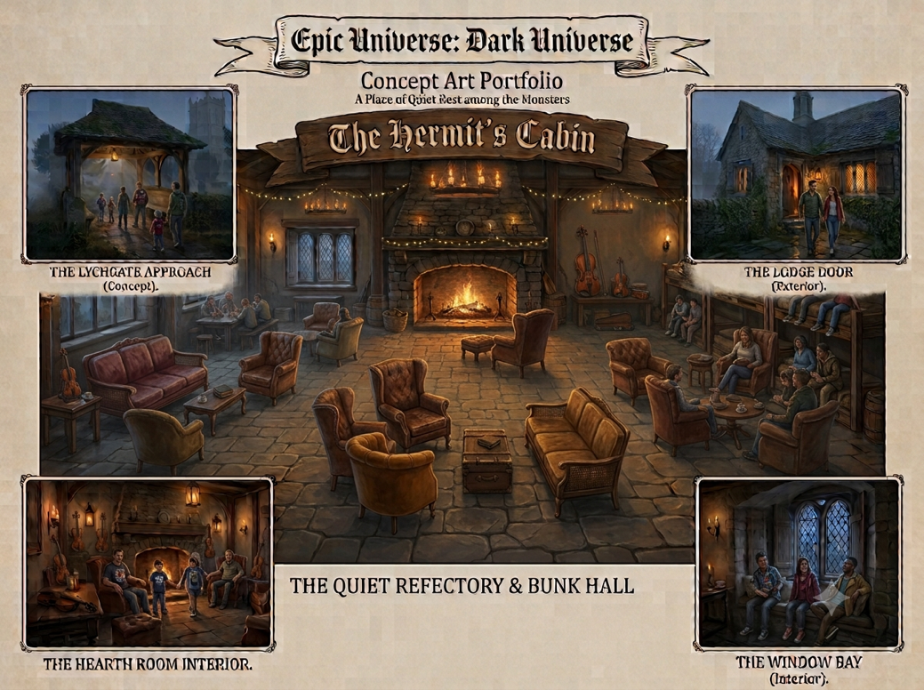
For example, in the Dark Universe portion of Epic Universe, guests will experience a calm respite of the Hermit’s cabin. There’s a scene in Bride of Frankenstein (1935) where the monster finds refuge at a hermit’s cabin. There, the monster learns about food and smoking. While this experience won’t teach guests about bad habits, it will be themed in such a manner. Before entering this cabin, guests will walk through a graveyard with tombstones. Many along the path to the entrance will teach guests about the expectations of the space. One such could read “May your devices be as silent as a grave”.
Figure 1: An AI-generated image of the Monster's themed Rest stop
As they enter the space, the veil of calmness starting outside continues by leading guests down a short hallway. They check in with an attendant and find a place among the chairs and tables. Their device contains their reservation’s start and end time. During that stay guests can participate in this rest stop.
The rooms the guests can enjoy consisting of a larger space and various smaller rooms. Guests are free to wander around and enjoy wherever they find an open space. Each room is equipped with setting-specific décor, but also modern amenities such as phone charging stations. Team members dressed in a theme-specific costume are in the space doing what they can to help the guests recharge.
Finally, when they’re ready to leave, they exit through another door. They pass a small guest-relations kiosk where they can get quick answers taken care of. Returning to the park, they experience a hallway that opens, becoming wider and brighter so the guest is ready to reenter the full Dark Universe experience.
More information about this experience is found here: https://jb-guest-experience.com/

